Q49: Write a program to print the following pattern:
5
45
345
2345
12345
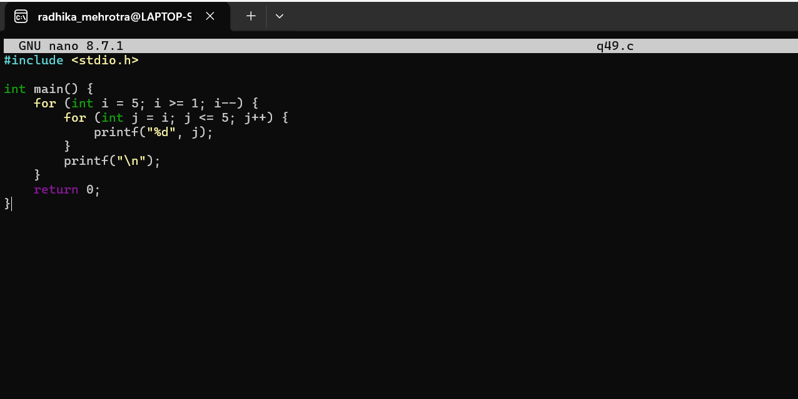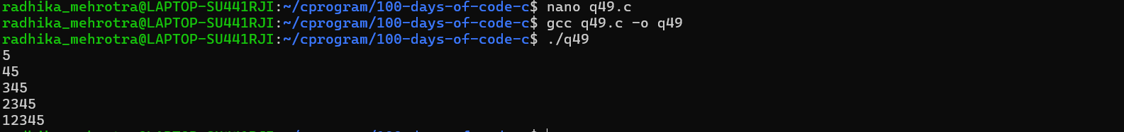
Q50 (Nested Loops without Arrays/Strings)📋
Write a program to print the following pattern:
*****
****
***
**
*
